2022212153 陈祥烨 第一章作业

**第一题**

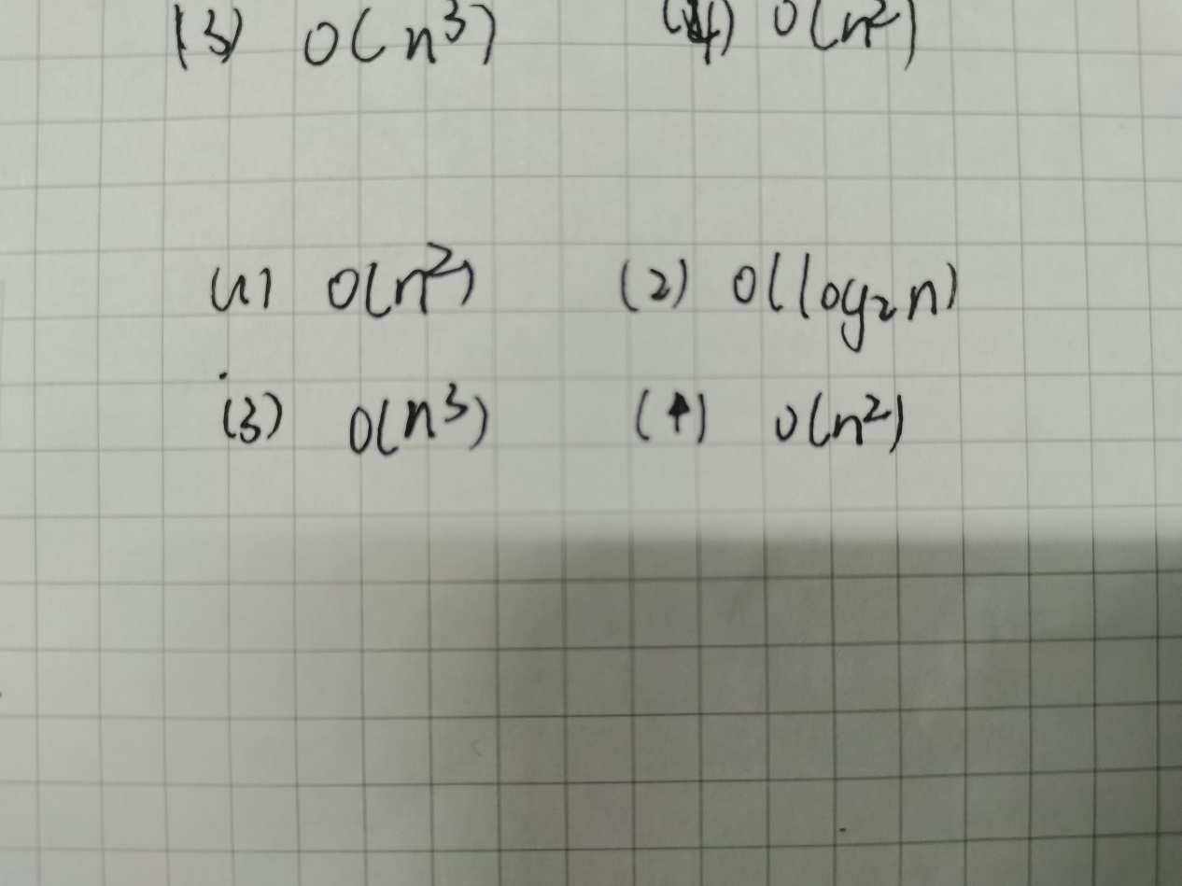

**第二题**

#include<iostream>

using namespace std;

double fun(int n, double x, double a[])

{

if (n == 0)

return a[n];

return fun(n - 1, x, a) * x + a[n];

}

int main()

{

cout << "请输入n(n<=100): ";

int n;

cin >> n;

cout << "请输入x：";

double x;

cin >> x;

cout << "请输入参数数组(从an开始)：";

double coefficient[100];

for (int i = 0; i < n+1; i++)

{

cin >> coefficient[i];

}

cout <<"结果是：" << fun(n,x, coefficient) << endl;

return 0;

}

**第三题**

#include<iostream>

using namespace std;

int j = 0;

void getson(int A[], int max)

{

//标记输出

A[1] += 1;

for (int i = 1; i <= max; i++)

{

if (A[i] == 2)

{

A[i] = 0;

A[i + 1] += 1;

}

}

//输出

cout << "{";

for (int i = 1; i <= max; i++)

{

if (A[i] == 1)

cout << i << ", ";

}

cout << "\b\b}" << endl;

j++;

if (j % 5 == 0)cout << endl;

//结束标志

int over = 0;

for (int i = 1; i <= max; i++)

{

over += A[i];

}

if (over == max)return;

getson(A, max);

}

int main()

{

int A[100]{ 0 };

int max;

cin >> max;

getson(A,max);

cout << "{}";

return 0;

}

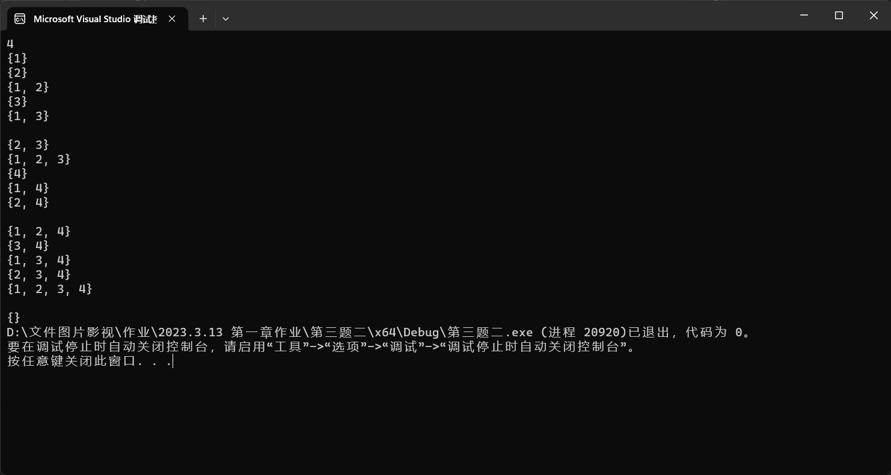

**第四题**

#include<iostream>

using namespace std;

void sort(int A[],int n)

{

int head = 0;

int rear = n-1;

while (head < rear)

{

while (A[head] % 2 == 1)

if (head < rear)

head++;

else

return;

while (A[rear] % 2 == 0)

if (head < rear)

rear--;

else

return;

swap(A[head], A[rear]);

}

}

int main()

{

cout << "请输入数组大小n(n<100)：";

int n;

cin >> n;

cout << "请输入数组元素：";

int A[100];

for (int i = 0; i < n; i++)

{

cin >> A[i];

}

sort(A,n);

cout << "排序后结果为：";

for (int i = 0; i < n; i++)

{

cout << A[i] << " ";

}

}

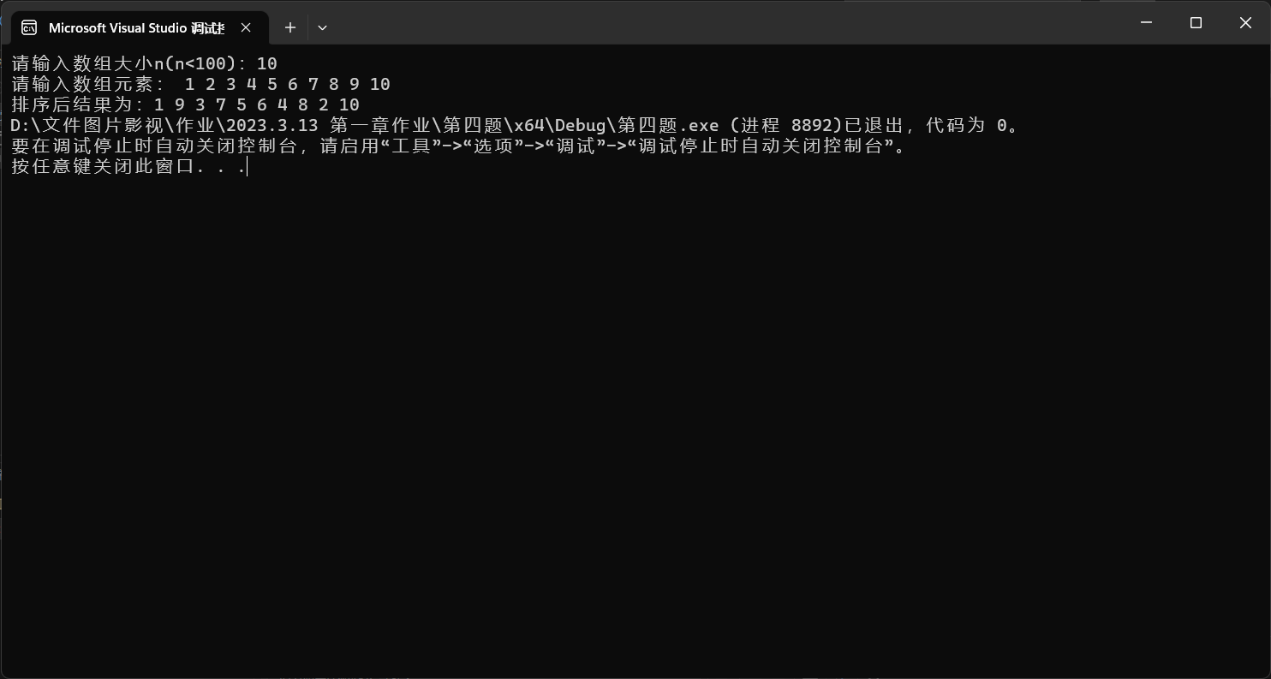

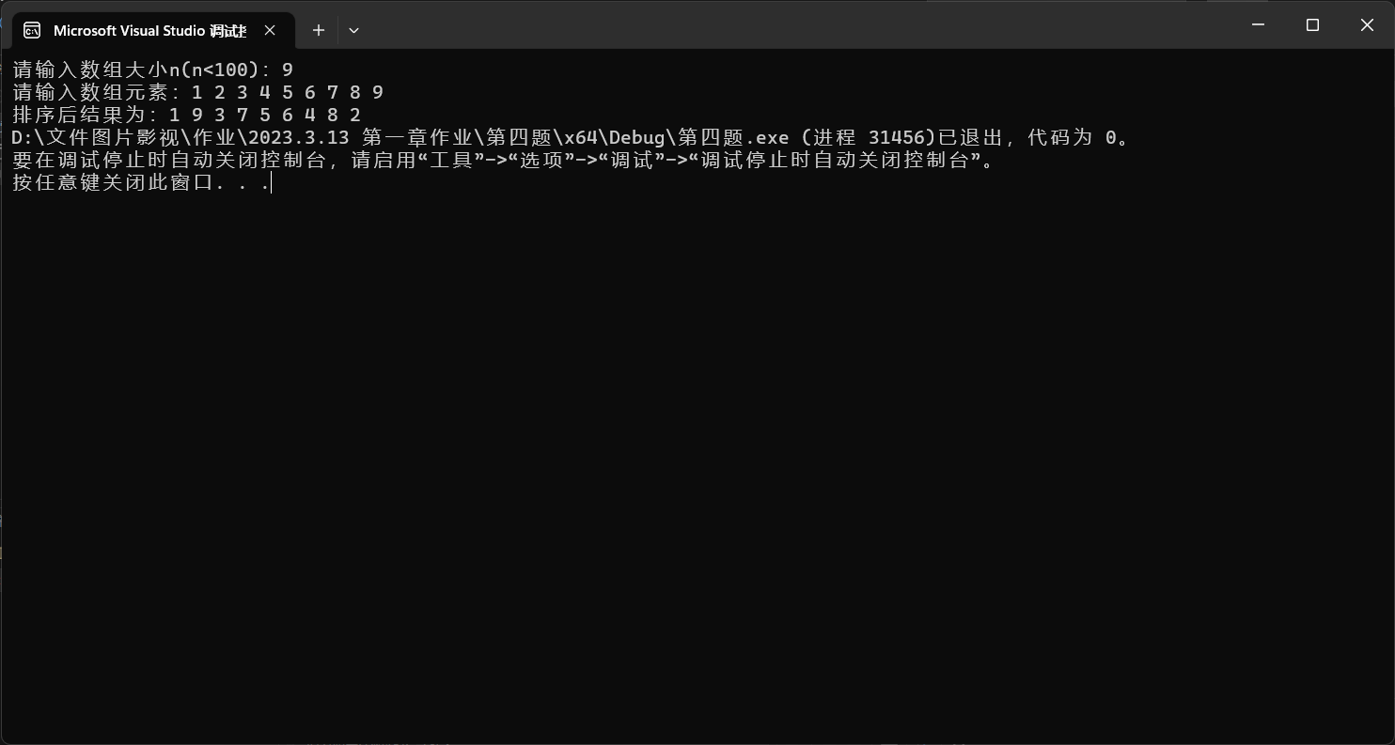

**第五题**

#include<iostream>

using namespace std;

int m = 0;

int n = 1;

void getdown(int max, int A[]);

void getup(int max, int A[]);

void getup(int max, int A[])

{

while (A[n] <= A[n + 1] && n < max - 1)

n++;

cout << "{";

for (int i = m; m <= n; m++)

if (m != n)

cout << A[m] << ",";

else

cout << A[m];

cout << "}";

if (n == max - 1)return;

n++;

m--;

getdown(max, A);

}

void getdown(int max, int A[])

{

while (A[n] >= A[n + 1] && n < max - 1)

n++;

cout << "{";

for (int i = m; m <= n; m++)

if (m != n)

cout << A[m] << ",";

else

cout << A[m];

cout << "}";

if (n == max - 1)return;

n++;

m--;

getup(max, A);

}

int main()

{

cout << "请输入数组大小n(n<100)：";

int max;

cin >> max;

cout << "请输入数组元素：";

int A[100];

for (int i = 0; i < max; i++)

{

cin >> A[i];

}

while (A[m] == A[n])

n++;

if (A[m] < A[n])

getup(max, A);

else

getdown(max, A);

return 0;

}

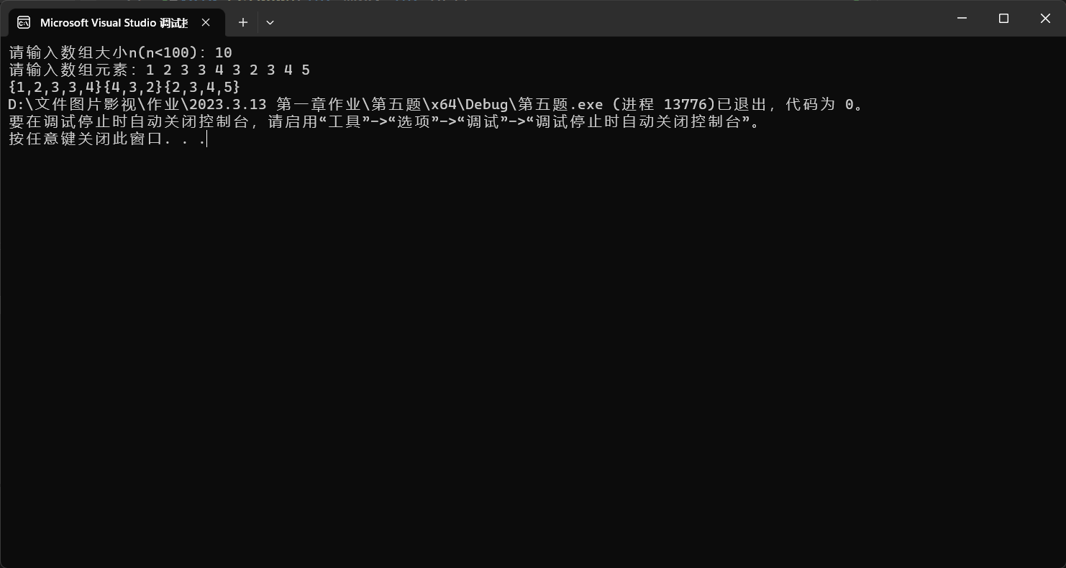

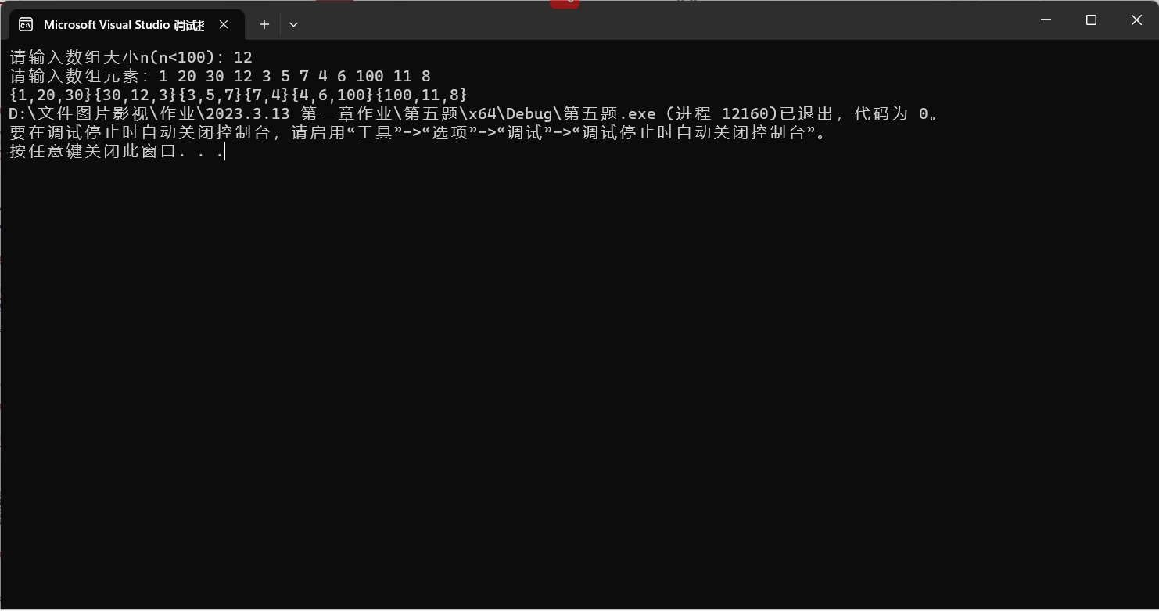

**第六题**

#include<iostream>

using namespace std;

struct thing

{

int data;

int sign;

};

void getresult(thing A[], int max,int S)

{

//标记拿出

A[1].sign += 1;

for (int i = 1; i <= max; i++)

{

if (A[i].sign == 2)

{

A[i].sign = 0;

A[i + 1].sign += 1;

}

}

//判断是否等于S

int sum = 0;

for(int i = 1; i <= max; i++)

{

if (A[i].sign == 1)

sum += A[i].data;

}

if (sum == S)

{

for (int i = 1; i <= max; i++)

{

if (A[i].sign == 1)

cout << "(" << i << ", " << A[i].data << ")"<<"\t";

}

cout <<endl<< endl;

}

//结束标志

int over = 0;

for (int i = 1; i <= max; i++)

{

over += A[i].sign;

}

if (over == max)return;

getresult(A, max,S);

}

int main()

{

int S;

cout << "input S:";

cin >> S;

cout << "input n:";

int max;

cin >> max;

cout << "input A[n]:"<<endl;

thing A[100];

for (int i = 1; i <= max; i++)

{

cin >> A[i].data;

A[i].sign = 0;

}

getresult(A, max,S);

return 0;

}

